**Lab 2 – Implementing Algorithms**



*All work must be uploaded on Webcourses by 6pm on Thursday.*

1. Complete the quiz in the *Week 3 Lab* folder. The final question in the quiz should be used for Q2. This is only available during class.
2. Implement the tree-drawing algorithm (derived in Thursday’s class and described in the following images) in C.

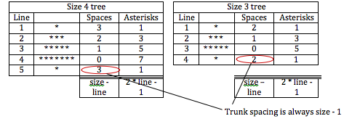

1. Document the pseudo code for the game – *Rock, Paper, Scissors*, started in the class on Thursday in a WORD document. Outline the rules involved in the game.
2. Using the Scratch project provided (**RockPaperScissors(start of).sb**), implement your algorithm in Scratch.
3. Play the following game – *Towers of Hanoi*:

<http://www.mathsisfun.com/games/towerofhanoi.html>

**Finally ….**

Put the following documents in a folder, zip the folder, and upload it in Webcourses in the submission icon provided:

* 1. A **word** document with the pseudo code from Q3.
  2. C program from Q2.
  3. Scratch program from Q4.

**\*\* All of this lab will go towards your final CA mark. Ensure this is your own work, as if there is evidence of copying you will receive 0.**